

Submitted by : Spogmai jan
Roll no : 2430 - 0081
Course : AI lab
Date of submission : 21/02/2026
Submitted to : MAM WARDAH

Assignment no : 02
Task 1:
Write a Python script to print a dictionary where the keys are numbers between 1 and 10 (both
included) and the values are square of keys. Sample Dictionary: {1: 1, 2: 4, 3: 9, 4: 16, 5: 25, 6:
36, 7: 49, 8: 64, 9: 81, 10: 100

Code and output:
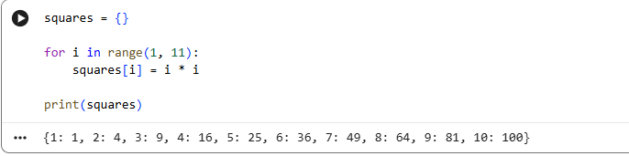

Task # 2:
Create a simple book inventory system using tuples. Each book in the inventory should be
represented as a tuple containing the following information:
• Title
• Author
• Publication Year
• ISBN (International Standard Book Number)
• Quantity in Stock
1. Define an empty list named book_inventory to store tuples representing books.
2. Implement a function add_book that takes input for a new book and adds it to the
book_inventory. The function should prompt the user for the book details (title, author,
publication year, ISBN, quantity) and create a tuple to represent the book. Append this
tuple to the book_inventory.
3. Implement a function search_book that takes the ISBN as input and searches for the book
in the inventory. If the book is found, print its details; otherwise, print a message indicating
that the book is not in the inventory.
4. Implement a function display_inventory that prints the details of all books in the inventory.
Each book&#39;s information should be printed on a new line.
5. Implement a function sell_book that takes the ISBN and quantity as input and updates the
stock quantity of the corresponding book in the inventory. If the quantity is greater than the
available stock, print a message indicating insufficient stock.
6. Test your inventory system by adding a few books, searching for them, displaying the
inventory, and selling books.

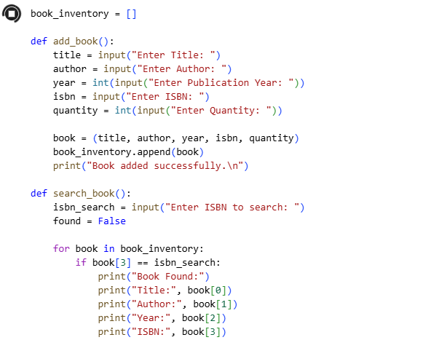
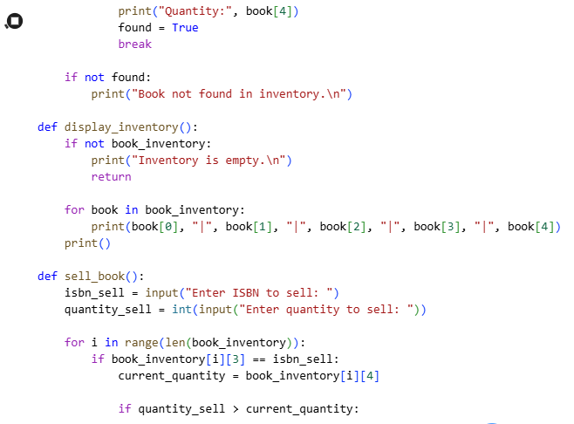
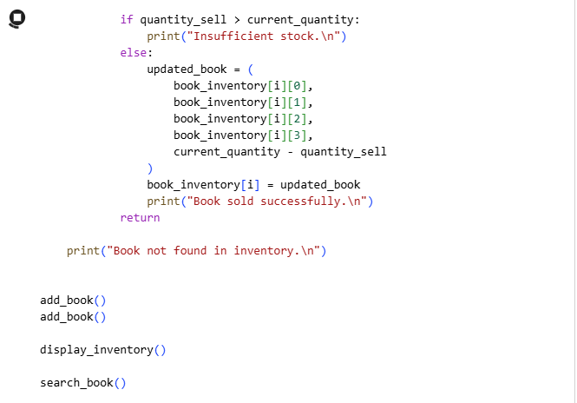

Output:
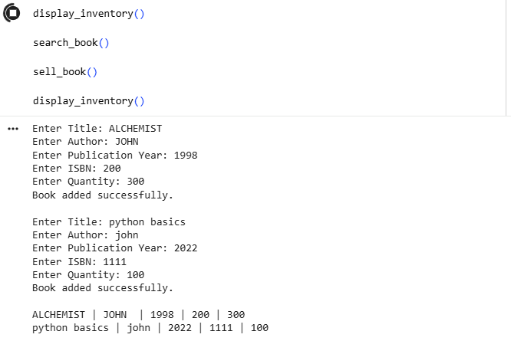
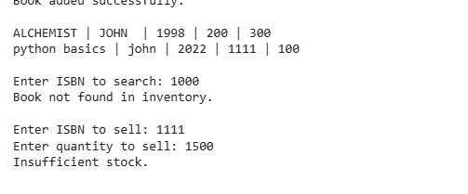

Task 03:
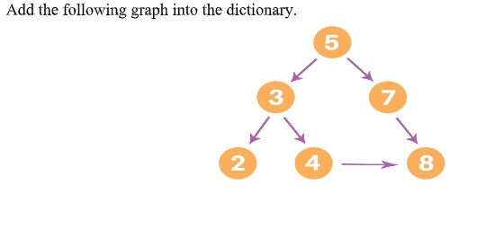
Code and output:
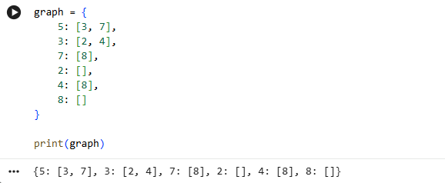

Task 04:
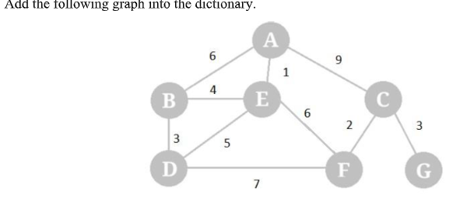
Code and output:



